
Join Our Team - Project Manager Vacancy
Grade 8, £39,152 (Term Time + 3 weeks) Actual Salary £35,405
Ref: TSH/PM
We are seeking an experienced manager who can support and coordinate multiple services and projects, acting as the key point of contact for all Generate Teaching Hub’s business. The ideal candidate will have excellent communication skills, be comfortable taking initiative, confident when networking with a range of stakeholders, be a positive team leader and relish creating systems that deliver high quality customer service.

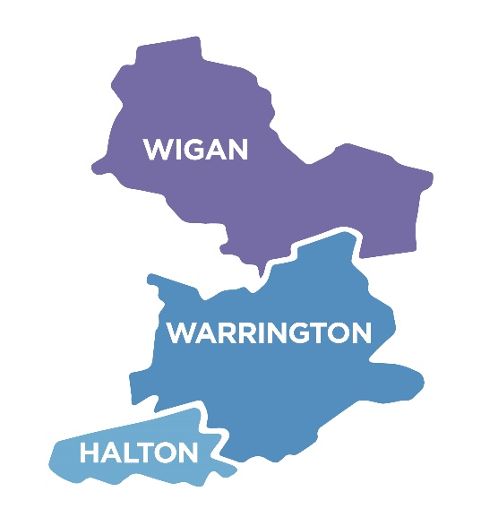
Generate Teaching Hub is a specialist service supporting teacher training and development across Halton, Warrington and Wigan. Chosen by the Department for Education, after a rigorous national commissioning process, our work is designated as just one of 87 Teaching School Hubs in England implementing national reforms to the training of teachers.

Working with over 220 schools, we have cohorts of learners involving trainee teachers, new and experienced teachers, plus school leaders taking part in a range of long term development programmes. The new Project Manager will be joining an established team of professionals with scope to continue the expansion and development of our operations.

Experience of education is not essential, we are seeking a high quality professional who has a clear understanding of our vision and approach.

The role is offered as a fixed term contract to 31st August 2028 with immediate start available if possible. Part time applicants, or flexible working requests, would be considered and we strongly encourage applications from diverse backgrounds.

Our office base is located in Kingsway Primary Academy, Widnes with regular contact / visits to stakeholder schools across our area.

The successful candidate will become part of a team employed by Warrington Primary Academy Trust (WPAT), a growing organisation that is passionate about continual improvement to ensure our children receive the best education available. WPAT provides all staff with access to a local government pension, staff care and wellbeing services and an individual programme of personal development.

To apply please complete an application form and return to dsharples@wpat.uk by 9am on Wednesday 28th January 2026. Interviews are provisionally arranged for Friday 6th February 2026.


A role description, person specification and application form are available here: Vacancies - Generate Teaching Hub

Informal conversations about the roles are welcome. To arrange a time to speak to the Head of Generate Teaching Hub please contact hub@wpat.uk.

